Julie Lam

Website Testing & Validation Report

Contents

Test Checklist 2

FunctionalityTesting 2

Compatibility Testing 2

Usability Testing 3

Standards Testing 4

Test Results 6

Functionality Testing 6

Compatibility Testing 6

Usability Testing 6

Standards Testing 6

Conclusion 6

# Test Checklist

## **Functionality** Testing

Functionality testing is a testing method primarily concerned with ensuring all functionality of the website operates as expected.

The following are the appropriate testcases to assess the functionality of the website:

All links redirects the user as appropriate

All website pages can be navigated to with internal links

## Compatibility Testing

Compatibility testing is a testing method primarily concerned with ensuring consistency of basic website features.

The following are the appropriate testcases to assess the compatibility of the website:

Website behaves consistently across two common browsers

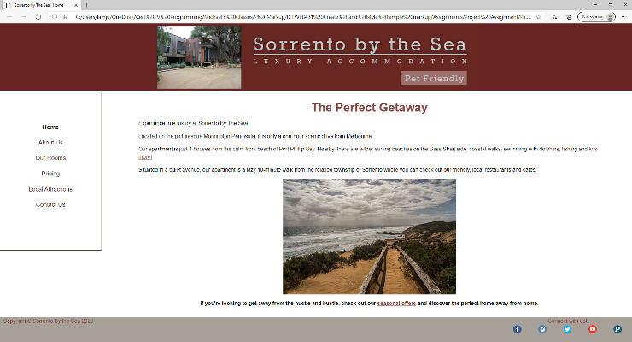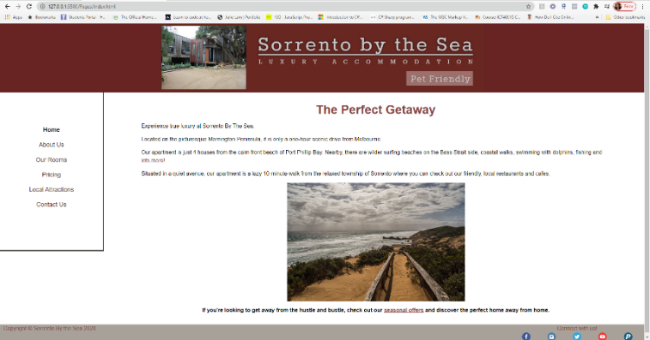

Figure . Example Deployment on Google Chrome

Figure 2. Example Deployment on Microsoft Edge

Website design is responsive across different screen sizes

## Usability Testing

Usability testing is a testing method primarily concerned with ensuring a positive user experience for website visitors.

The following are the appropriate testcases to assess the usability of the website:

Content is accurate and free of spelling/grammatical errors

Main menu is accessible on all individual pages

Fonts match requirements

Users experience a hassle-free, user-friendly experience while navigating this website to answer the following questions:

* [Question 1]
* [Question 2]
* [Question 3]

## Standards Testing

Markup meets W3.org specification standards

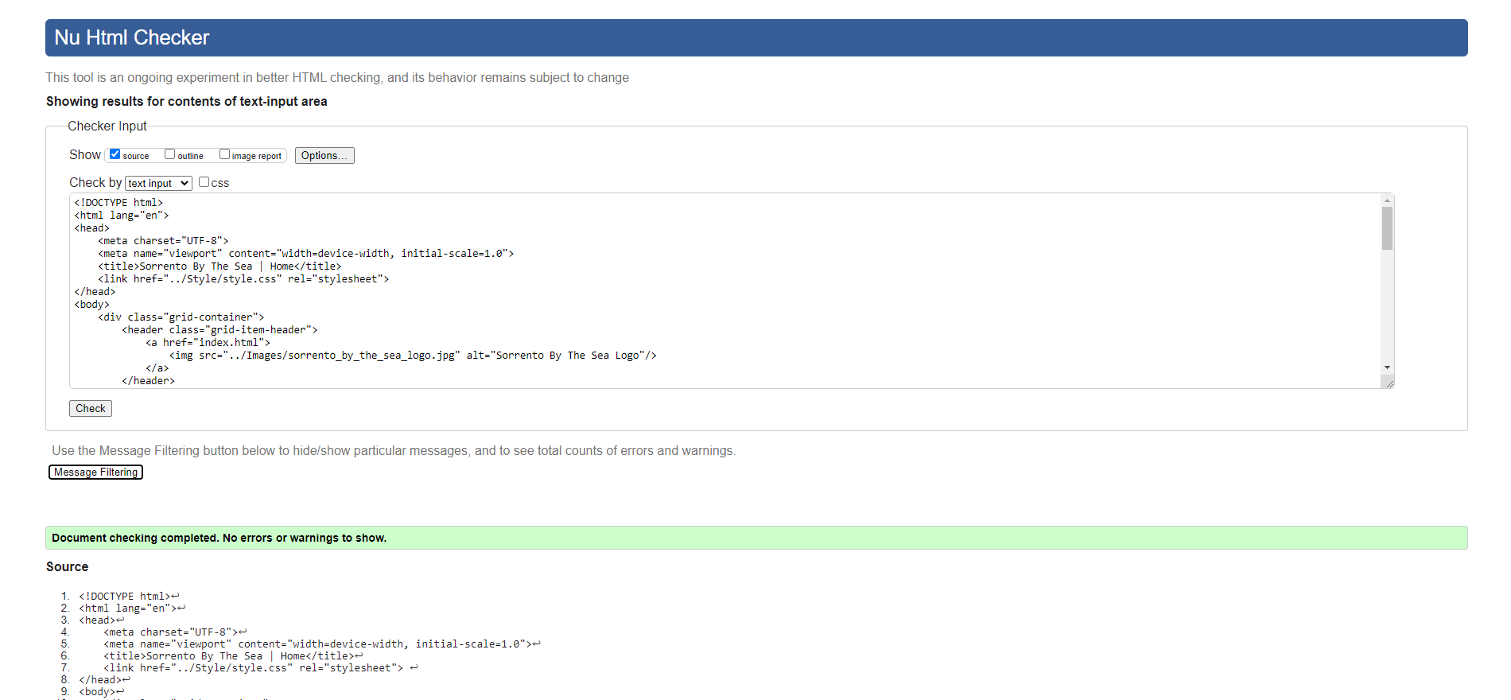

Figure 3. Home Page Validated

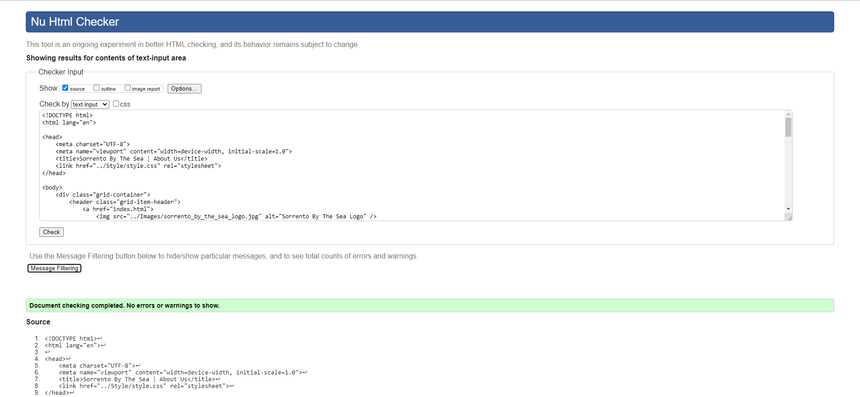

Figure 4. About Us Page Validated

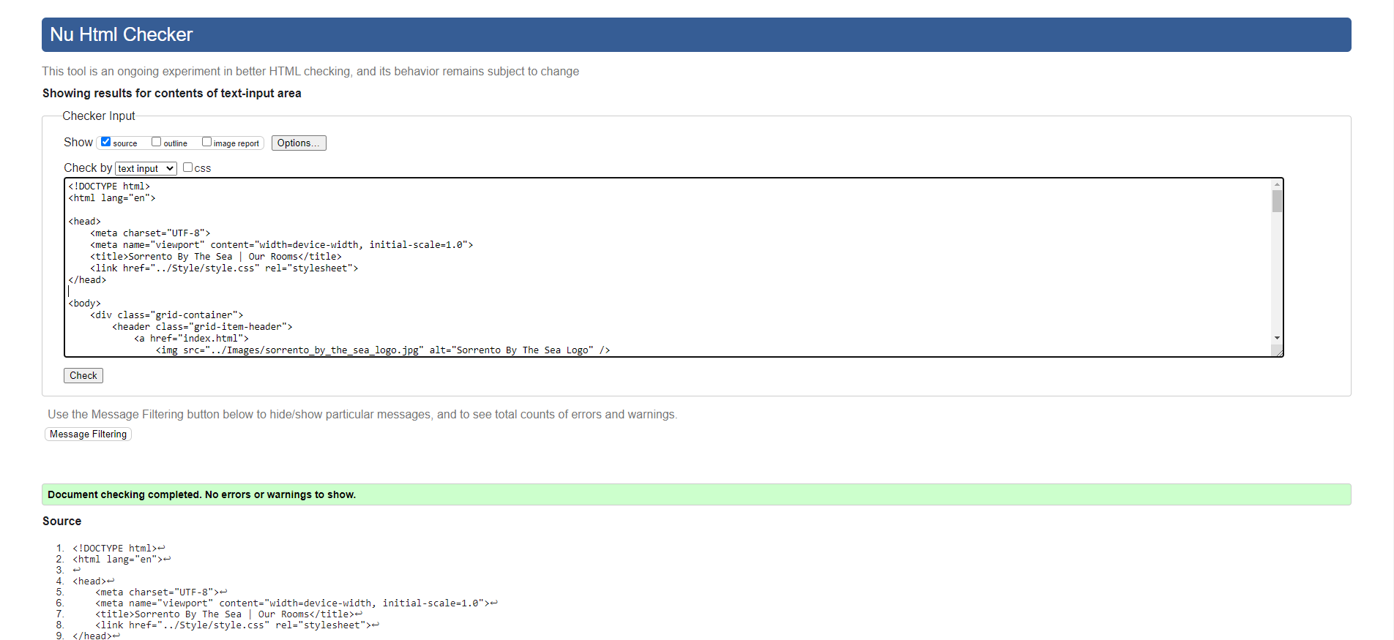

Figure 5. The Rooms Page Validated

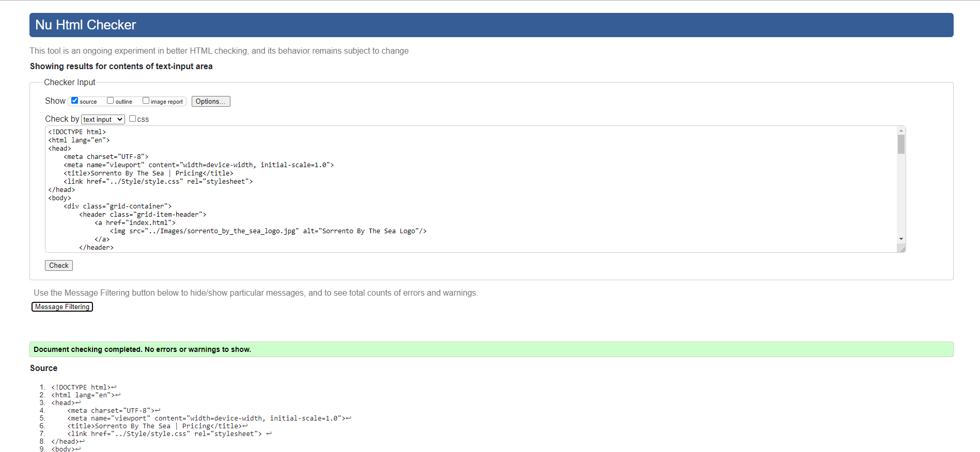

Figure 6. Pricing Page Validated

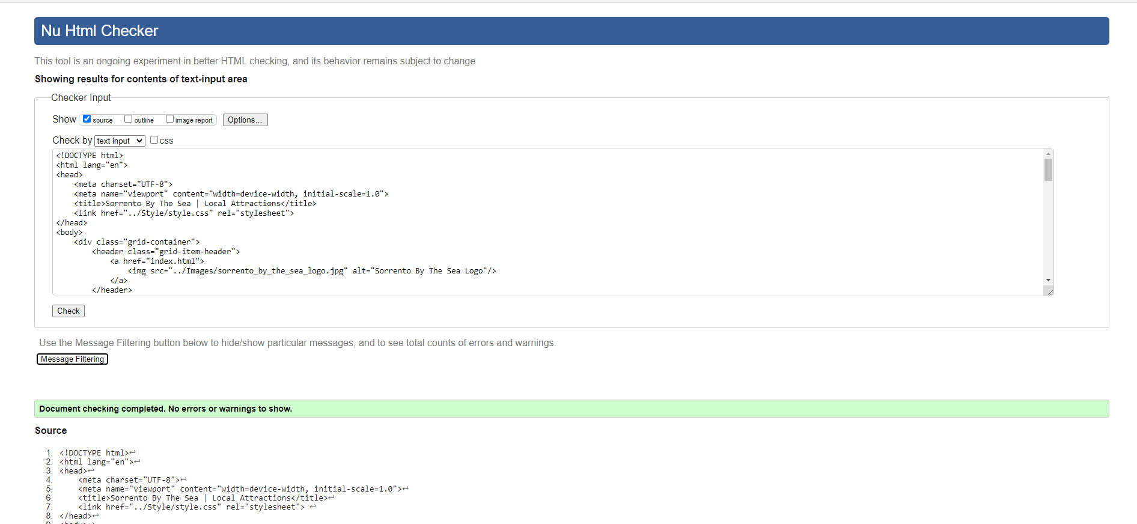

Figure 7. Local Attractions Page Validated

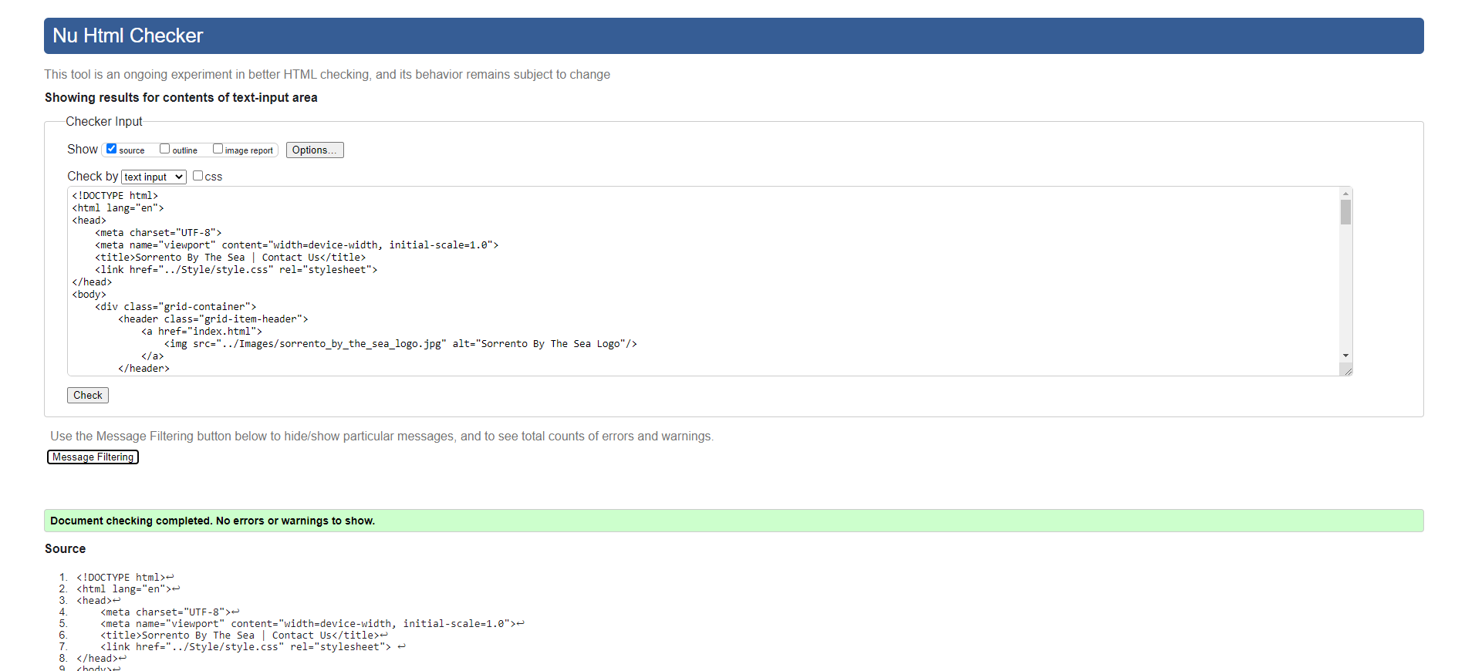

Figure 8. Contact Us Page Validated

CSS meets W3.org specification standards

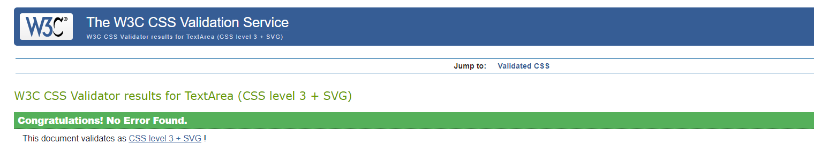

Figure 9. style.css Stylesheet Validated



Figure 10. print.css Stylesheet Validated

# Test Results

## Functionality Testing

## Compatibility Testing

## Usability Testing

## Standards Testing

## Conclusion